COMPLAINT MANAGEMENT SYSTEM
@CREATIVITY THINK (9483175986/7019689991)

ABSTRACT:
Complaint Management System is a web application designed for estates, municipal bodies, and workplaces to efficiently log, track, and resolve complaints. Users can submit complaints, monitor status, receive notifications, and access dashboards. Administrators manage complaints, assign resolvers, and analyze dashboard data. The backend leverages Django and Django Rest Framework for secure data handling, authentication, and business logic, while the frontend uses React, Redux, and Axios for responsive interfaces. This system ensures transparent complaint management, real-time tracking, and streamlined administrative oversight..

INTRODUCTION OF THE PROJECT:
Managing complaints in large organizations or public bodies can be challenging due to delays, lack of tracking, and inefficient assignment of issues. Complaint Management System provides a web platform for users to log complaints, track progress, receive notifications, and view dashboards. Administrators can efficiently manage complaints, assign resolvers, and monitor analytics for performance and resolution times. Using Django and Django Rest Framework for the backend and React with Redux on the frontend ensures a secure, responsive, and interactive complaint handling system..

PROJECT OBJECTIVES:

• Enable users to log complaints easily
• Provide real-time tracking of complaint status
• Notify users of updates and resolutions
• Assign complaints to appropriate resolvers efficiently
• Provide administrators with dashboards and analytics
• Streamline complaint resolution processes
• Ensure transparency and accountability in complaint handling

PROBLEM OF THE STATEMENT:
Inefficient complaint handling causes delays, lack of transparency, and poor accountability in workplaces, estates, or municipal bodies. Users often cannot track the status of their complaints, while administrators struggle to assign, monitor, and resolve issues promptly. Complaint Management System addresses these challenges by providing a web-based platform for complaint logging, real-time tracking, notification alerts, resolver assignment, and administrative dashboards, ensuring faster resolution, accountability, and improved satisfaction for all stakeholders..

MOTIVATION OF THE PROJECT:
• Facilitate quick and efficient complaint logging
• Enhance transparency in complaint tracking
• Improve accountability for resolution processes
• Provide administrators with comprehensive dashboards
• Reduce delays and streamline complaint management

BLOCK DAIGRAM OF PROJECT:

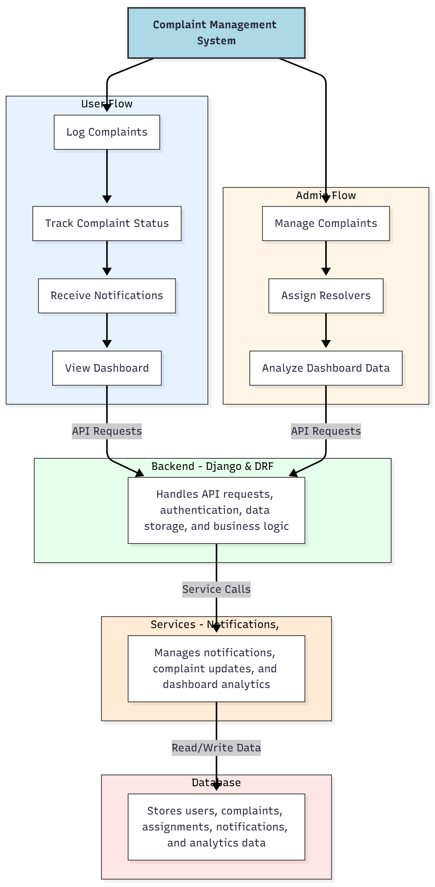

WORKING OF THE PROJECT:
Users submit complaints, track their status, receive real-time notifications, and view dashboards summarizing complaint progress. The backend handles API requests, authentication, storage, and business logic for complaints. Services manage notifications and analytics updates. Administrators review complaints, assign resolvers, and analyze dashboard metrics. This ensures timely complaint resolution, transparent tracking, and efficient administrative oversight for estates, workplaces, and municipal bodies..

SOFTWARE REQUIREMENT:
- Backend:
  - Python 3.x
  - Django
  - Django REST Framework
  - SQLite/PostgreSQL
- Frontend:
  - Node.js and npm
  - React.js
  - Axios
- Development Tools:
  - Visual Studio Code
  - Postman (for testing APIs)
  - Git/GitHub (for version control)
- Server/Deployment (Optional):
  - Gunicorn, Nginx, or Heroku/AWS for hosting

ADVANTAGES OF THE PROJECT:

• Real-time complaint logging and tracking
• Transparent resolution process
• Efficient assignment of complaints to resolvers
• Notifications for users and admins
• Comprehensive analytics dashboards
• Streamlined administrative oversight
• Improved accountability and performance
• Accessible web-based platform for multiple domains

APPLICATIONS OF THE PROJECT:
• Residential estates and housing societies
• Municipal bodies for public complaints
• Workplace grievance tracking
• Educational institution complaint management
• Maintenance request management
• Real-time notifications for users and admins
• Dashboard-driven analytics for administrators
• Ensuring accountability and timely resolutions

REFERENCES:

- Django REST Framework Documentation — Django Software Foundation. Django Documentation. Available: https://docs.djangoproject.com/
- Django REST Framework. DRF Documentation. Available: https://www.django-rest-framework.org/
- React. React Official Documentation. Available: https://reactjs.org/docs/getting-started.html
- Redux. Redux Documentation. Available: https://redux.js.org/introduction/getting-started
- PostgreSQL Global Development Group. PostgreSQL Documentation. Available: https://www.postgresql.org/docs/
- MySQL. MySQL Reference Manual. Available: https://dev.mysql.com/doc/
- Git. Git Documentation. Available: https://git-scm.com/doc
- Node.js. Node.js Documentation. Available: https://nodejs.org/en/docs/
- Axios. Axios Documentation. Available: https://axios-http.com/docs/intro
- Socket.io Documentation – https://socket.io/docs/

